3-Phase Induction Motor

An [electrical motor](https://www.electrical4u.com/electrical-motor-types-classification-and-history-of-motor/) is such an electromechanical device which converts electrical energy into a mechanical energy. In case of three phase AC operation, most widely used motor is **Three phase induction motor** as this type of motor does not require any starting device or we can say they are self starting induction motor.  
For better understanding the **principle of three phase induction motor**, the basic constructional feature of this motor must be known to us. This Motor consists of two major parts:  
**Stator:**  
**Stator of three phase induction motor** is made up of numbers of slots to construct a 3 phase winding circuit which is connected to 3 phase AC source. The three phase winding are arranged in such a manner in the slots that they produce a rotating [magnetic field](https://www.electrical4u.com/what-is-magnetic-field/) after 3Ph. AC supply is given to them.

**Rotor:**   
**Rotor of three phase induction motor** consists of cylindrical laminated core with parallel slots that can carry conductors. [Conductors](https://www.electrical4u.com/electrical-conductor/) are heavy copper or aluminum bars which fits in each slots & they are short circuited by the end rings. The slots are not exactly made parallel to the axis of the shaft but are slotted a little skewed because this arrangement reduces magnetic humming noise & can avoid stalling of motor.

Rotor Types and Reatures:

**Squirrel Cage Rotor**

[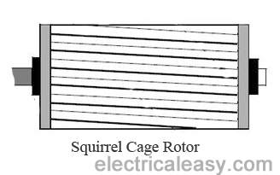](http://1.bp.blogspot.com/-XKgw-Ok4Mz4/UwmFbk7-nFI/AAAAAAAAAgY/yXdwaLiXKqQ/s1600/squirrel-cage-rotor.png)

Most of the induction motors (upto 90%) are of squirrel cage type. **Squirrel cage type rotor** has very simple and almost indestructible construction. This type of rotor consist of a cylindrical laminated core, having parallel slots on it. These parallel slots carry rotor conductors. In this type of rotor, heavy bars of copper, aluminum or alloys are used as rotor conductors instead of wires.  
Rotor slots are slightly skewed to achieve following advantages -

1. it reduces locking tendency of the rotor, i.e. the tendency of rotor teeth to remain under stator teeth due to magnetic attraction.

2. increases the effective transformation ratio between stator and rotor

3. increases rotor resistance due to increased length of the rotor conductor

The rotor bars are brazed or electrically welded to short circuiting end rings at both ends. Thus this rotor construction looks like a squirrel cage and hence we call it. The rotor bars are permanently short circuited, hence it is not possible to add any external resistance to armature circuit.

**Phase Wound Rotor**

[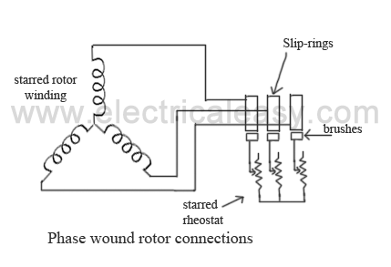](http://4.bp.blogspot.com/-B79l1iEqcpI/UwmF1XIQf_I/AAAAAAAAAgg/-hMD1Spjbn4/s1600/phase-wound-rotor.png)**Phase wound rotor** is wound with 3 phase, double layer, distributed winding. The number of poles of rotor are kept same to the number of poles of the stator. The rotor is always wound 3 phase even if the stator is wound two phase.  
The three phase rotor winding is internally star connected. The other three terminals of the winding are taken out via three insulated sleep rings mounted on the shaft and the brushes resting on them. These three brushes are connected to an external star connected rheostat. This arrangement is done to introduce an external resistance in rotor circuit for starting purposes and for changing the speed / torque characteristics.  
When motor is running at its rated speed, slip rings are automatically short circuited by means of a metal collar and brushes are lifted above the slip rings to minimize the frictional losses.

##.......How does 3 phase supply produce Rotating Flux…………?

Rotating Magnetic Field
EI-DEPT, SRMCEM, LUCKNOW 4
6) PRODUCTION OF ROTATING MAGNETIC FIELD
Consider a three phase winding...

Rotating Magnetic Field
EI-DEPT, SRMCEM, LUCKNOW 5
Let ∅1, ∅2, and ∅3 be the instantaneous values of the fluxes. The resul...

Rotating Magnetic Field
EI-DEPT, SRMCEM, LUCKNOW 6
CASE 2: θ=60°
Substituting in equations 1), (2), (3) we get,
=
So is po...

Rotating Magnetic Field
EI-DEPT, SRMCEM, LUCKNOW 7
FIGURE: 8. VECTOR DIAGRAM FOR =120° [1]
∅T = 1.5∅m
So magnitude of the ...**Comparison of induction motor with a transformer:**

|  |
| --- |
| [https://4.bp.blogspot.com/-M5LdfkdOjwM/V9evADLHv5I/AAAAAAAAfbA/SSVob2G8ZBY_SaOdHAQDcDQDYKDKo2iXQCLcB/s320/tmp395_thumb3.jpg](https://4.bp.blogspot.com/-M5LdfkdOjwM/V9evADLHv5I/AAAAAAAAfbA/SSVob2G8ZBY_SaOdHAQDcDQDYKDKo2iXQCLcB/s1600/tmp395_thumb3.jpg) |
| Figure: Sketch showing similarity between transformer and induction motor |

The transfer of energy from stator to the rotor of an induction motor takes place entirely inductively with the help of flux mutually linking the two. Hence an induction motor is essentially a transformer with stator forming the primary and rotor forming the rotating secondary.

|  |  |
| --- | --- |
| **Transformer** | **Induction Motor** |
| (1) Secondary is stationary | (1) Secondary winding is rotating |
| (2) Secondary is not short circuited | (2) Secondary is always short circuited |
| (3) No-load current is about 1% of full load | (3) No-load current is approximately 30 to 50% current (due to low reluctance path   of full current (due to high reluctance of steel core)  of air gap) |
| (4) emf induced in secondary depends on   K (turns ratio) | (4) Depends on K and slip also |
| (5) Frequency of primary and secondary currents  are same | (5) Frequency of stator current (f) and rotor current (sf) are not the same. |

### Principle of Operation

For explaining the principle of operation of a three phase induction motor, consider a portion of three phase induction motor as shown in the figure. The operation of the motor can be explained as under:

* When three phase stator winding of an induction motor is energized from a 3 phase supply, a rotating magnetic field is set up which rotates round the stator at synchronous speed (Ns = 120 f/P).

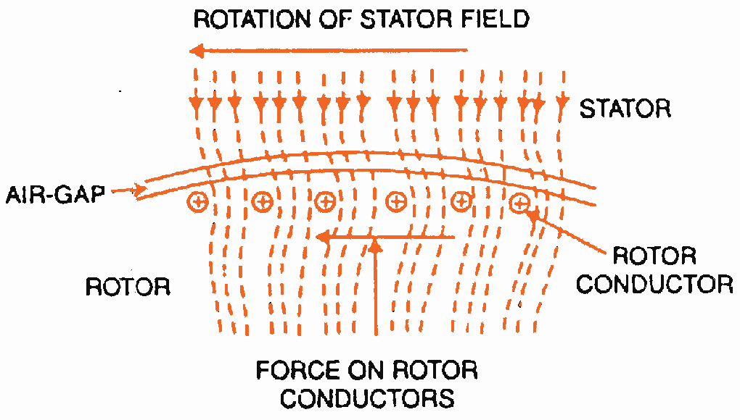

* The rotating field passes through the air gap and cuts the rotor conductors, which as yet, are stationary. Due to the relative speed between the rotating flux and the stationary rotor, e.m.f.s are induced in the rotor conductors. Since the rotor circuit is short-circuited, currents start flowing in the rotor conductors.
* The current-carrying rotor conductors are placed in the magnetic field produced by the stator. Consequently, mechanical force acts on the rotor conductors. The sum of the mechanical forces on all the rotor conductors produces a torque which tends to move the rotor in the same direction as the rotating field.
* The fact that rotor is urged to follow the stator field (i.e., rotor moves in the direction of stator field) can be explained by Lenz’s law. According to this law, the direction of rotor currents will be such that they tend to oppose the cause producing them.
* Now, the cause producing the rotor currents is the relative speed between the rotating field and the stationary rotor conductors. Hence to reduce this relative speed, the rotor starts running in the same direction as that of stator field and tries to catch it.

The rotor speed (N) of a three phase induction motor is always less than the stator field speed (Ns). This difference in speed depends upon load on the motor. The difference between the synchronous speed Ns of the rotating stator field and the actual rotor speed N is called slip.

# **Equivalent Circuit of a Three Phase Induction Motor**

In a [three phase induction motor](http://www.mytech-info.com/2015/01/introduction-of-three-phase-induction.html) the stationary winding is connected to the three phase supply and rotor winding is short circuited. The energy from the stator winding is transferred magnetically to the short circuited rotor winding. Thus the induction motor might be deliberated to be a [transformer](http://www.mytech-info.com/2013/09/basic-working-principle-of-transformer.html) with secondary winding (rotor short circuited winding). The stator windings refer to the primary of transformer and the rotor windings refer to the secondary of transformer. In view of the comparison of flux and conditions of voltage in a transformer, each can assume that the induction motor equivalent circuit and transformer equivalent circuit will be same. The figure below shows that per phase equivalent circuit on an induction motor.

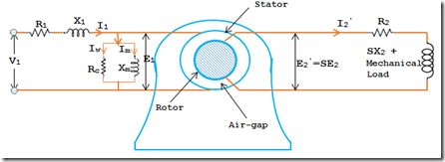

### Stator Circuit:

EMF E2’ is induced in the secondary winding (rotor winding). The drift of stator current I1 causes voltage drops in R1 and X1.

**V1 = -E1 + I1 (R1 + jX1)**

represents the no load motor losses and the production of magnetic flux respectively.

**I0 = Iw + Im**

### Rotor Circuit:

The induced voltage per phase in the rotor circuit is E2’ = SE2 = SKE1. The whole EMF E2’ is employed in circulating the rotor current I2’, since the rotor winding is short circuited.

**E2’ = I2’ (R2 + jSX2)**

**= 120f’/P**

**= 120SF/P**

**= SNs**

**= SNs + N**

**= (Ns – N) + N = Ns**

In consequence no matter what the value of slip, the magnetic fields of the stator and rotor are synchronous with each other. As a result the three phase induction motor can be considered as being equivalent to a transformer having an air gap splitting the iron portions of the magnetic circuit carrying the primary winding and secondary winding. The Figure below shows that phasor diagram of an induction motor.

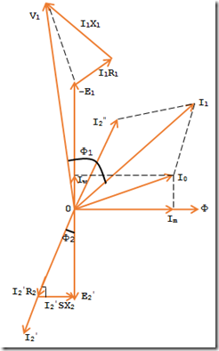

# **Power Stages in an Induction Motor**

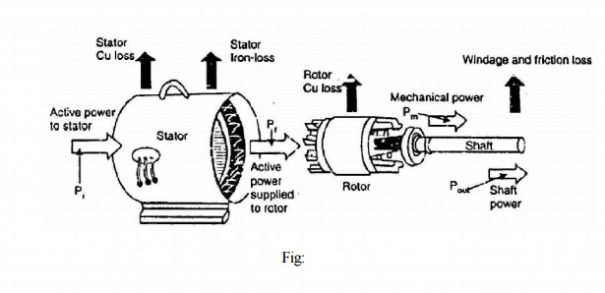

The following points may be noted from the above diagram:

(i)                          Stator input, Pi = Stator output + Stator losses

  =  Stator output + Stator Iron loss + Stator Cu loss

(ii)                        Rotor input, Pr = Stator output

 It is because stator output is entirely transferred to the rotor through air-gap by electromagnetic induction.

(iii) Mechanical power available, Pm = Pr - Rotor Cu loss

 This mechanical power available is the gross rotor output and will produce a gross torque Tg.

(iv) Mechanical power at shaft, Pout = Pm - Friction and windage loss

Mechanical power available at the shaft produces a shaft torque Tsh.

**Why is star delta starter preferred with an induction motor?**

At the time of starting an Induction motor tends to draw high-current (7to8 times higher than rated current ) . In small motors (<5hp) it's okay . But for larger motor the starting current may be so high that it may damage the stator coil or even the power cables .

Star-Delta starter is used to reduce the starting current . Initially the motor windings are connected in star pattern . Then after a preset time the contactors make a delta pattern and the motor runs . While connected in star pattern , voltage across the stator coils is equal to the phase voltage (line voltage /1.3 aprox) , so the value of starting current is reduced .

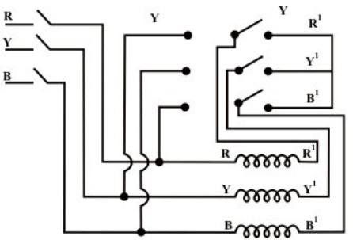

**Why is Three Phase Induction Motor Self Starting?**

In [three phase system](https://www.electrical4u.com/three-phase-circuit-star-and-delta-system/), there are three single phase line with 120o phase difference. So the rotating magnetic field is having the same phase difference which will make the rotor to move. If we consider three phases a, b and c, when phase a is magnetized, the rotor will move towards the phase a winding a, in the next moment phase b will get magnetized and it will attract the rotor and then phase c. So the rotor will continue to rotate.

SIGNIFICANT OF SLIP***********************

Slip is a measure of the difference in relative motion between the rotor and the magnetic field set up by the field windings.  
  
In very simple terms, without **slip** an induction motor would not be able to develop any torque! A slip of zero means that the rotor is turning at synchronous speed; in other words it is running at the same speed as the rotating field set up by the field windings, so there is no relative movement between the field and the rotor. To develop torque, the voltages must be induced into the rotor, and this can only happen if there is relative movement between the field and the rotor -in other words, the rotor MUST be running more slowly than synchronous speed. That is, there must be some degree of slip.

# Circle Diagram of Induction Motor

The **circle diagram of an induction motor** is very useful to study its performance under all operating conditions. The “CIRCLE DIAGRAM” means that it is figure or curve which is drawn has a circular shape. As we know, the diagrammatic representation is easier to understand and remember compared to theoretical and mathematical descriptions.

## Importance of Circle Diagram

The diagram provides information which is not provided by an ordinary phasor diagram. A phasor diagram gives relation between [current](https://www.electrical4u.com/electric-current-and-theory-of-electricity/) and [voltage](https://www.electrical4u.com/voltage-or-electric-potential-difference/) only at a single circuit condition. If the condition changes, we need to draw the phasor diagram again.

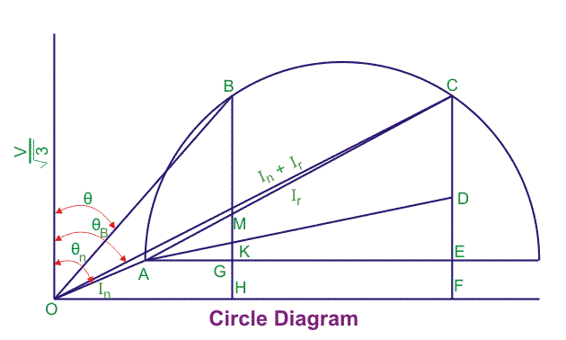

1. The no load current and the no load angle calculated from no load test is plotted. This is shown by the line OA, where Ɵ0 is the no load power factor angle.
2. The short circuit current and the angle obtained from block rotor test is plotted. This is shown by the line OC and the angle is shown by ƟB.
3. The right bisector of the line AC is drawn which bisects the line and it is extended to cut in the line AE which gives us the centre.
4. The stator current is calculated from the equivalent circuit of the induction motor which we get from the two tests. That current is plotted in the circle diagram according to the scale with touching origin and a point in the circle diagram which is shown by B.
5. The line AC is called the power line. By using the scale for power conversion that we have taken in the circle diagram, we can get the output power if we move vertically above the line AC to the periphery of the circle. The output power is given by the line MB.
6. The total copper loss is given by the line GM.
7. For drawing the torque line, the total copper loss should be separated to both the rotor copper loss and stator copper loss. The line DE gives the stator copper loss and the line CD gives the rotor copper loss. In this way, the point E is selected.
8. The line AD is known as torque line which gives the torque developed by induction motor.